

MOI HIGH-KABARAK 2025 PREDICTION
Kenya Certificate of Secondary Education
KCSE PREDICTION SERIES 1
441/2 Home Science Paper 2
(Clothing Construction)
Time: 2½ Hours

SCHOOL……………………………………………… SIGN…………………………..

Kenya Certificate of Secondary Education.

CONFIDENTIAL
Instructions to schools
The following materials will be provided by the school:
- Plain lightweight cotton fabric 55cm long by 90cm
- Sewing cotton thread to match the fabric
- One embroidery thread to be used by all students.

NB:FABRICS IN EXCESS OF THE AMOUNT MUST NOT BE SUPPLIED TO THE CANDIDATES
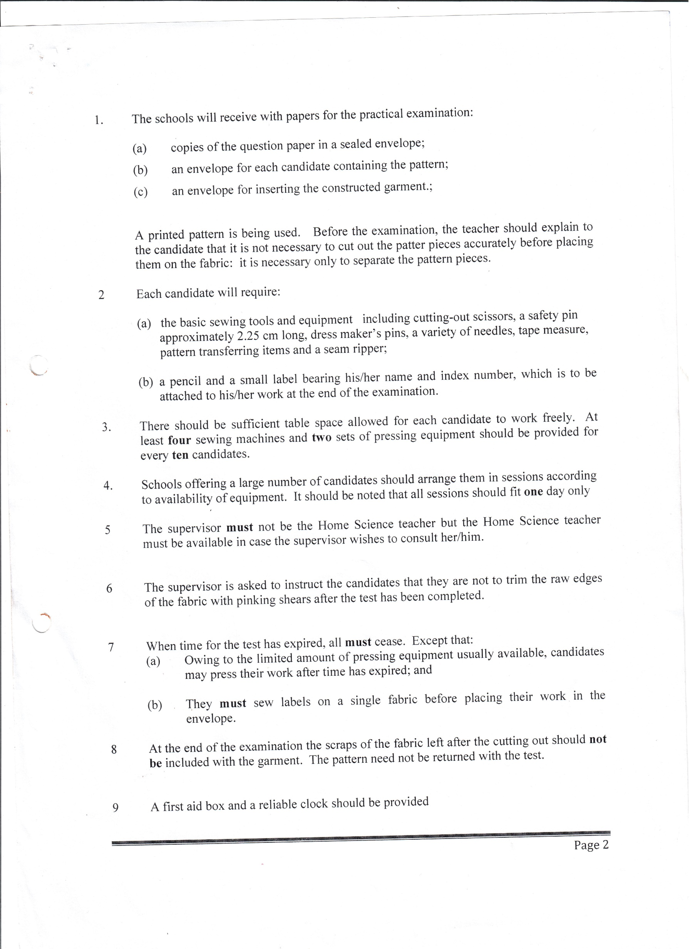



MOI HIGH-KABARAK 2025 PREDICTION
Kenya Certificate of Secondary Education
KCSE PREDICTION SERIES 1
441/2 Home Science Paper 2
Time: 2½ Hours

NAME…………………………………………………………………………………………
SCHOOL……………………………………………… SIGN…………………………..
INDEX NO……………………………………………. ADM NO………………………

Kenya Certificate of Secondary Education.

HOMESCIENCE
Paper 2
2 ½ hours

INSTRUCTIONS TO CANDIDATES.
- This paper consists of THREE printed pages
- Candidates should check the question paper to ascertain that all the pages are printed as indicated and that no questions are missing.

A pattern of a Childs bodice is provided.
You are advised to study the sketches, instructions and the layout before you begin the test.
Materials provided:

- PATTERN PIECES
- FRONT BODICE
- BACK BODICE
- BACK YOKE
- COLLAR
- BACKNECK FACING
- Plain lightweight cotton fabric 55cm by 91cm wide
- Sewing thread to match
- Embroidery thread (one to be used by all candidates)
- One large envelope.

THE TEST.
Using the materials provided, lay out, cut out and make THE LEFT HALF of Childs dress bodice to show the following processes;
- Cutting out 12 ½ mks
- Making the bust dart 8 mks
- Preparation and top stitching of inverted pleat 5 mks
- Attaching the back yoke to the back bodice and using the an
overlaid seam (Neaten half of it) 8mks
- Preparation of machine fell seam on the shoulder 12mks
- Preparing the interfaced collar demonstrate snipping on the collar 6mks
- Joining the back neck facing to the extended front facing and using it to attach the collar (Neaten the free edges of facing) demonstrate snipping on neckline. 15mks
- Working an open seam on the side seam 9mks
- Working of the buttonhole with rounded ends 4mks
- Embroidering the scroll at the bodice front using chain stitches 6 ½ mks
